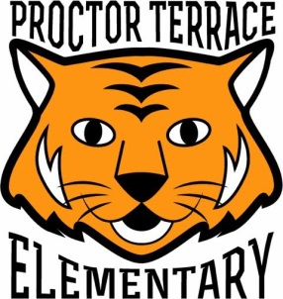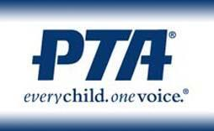
Proctor Terrace PTA
1711 Bryden Lane
Santa Rosa, CA 95404
www.ProctorTerracePTA.org

Dear Friends of Proctor Terrace Elementary School,

Proctor Terrace Elementary school's annual “Dinner, Dance and Auction” will be on Saturday, March 28, 2020,
at the Saturday Afternoon Club in Santa Rosa. The PTA relies heavily on this event to raise critical funds that support valuable education and enrichment programs, technology and software, and safe facilities for our children. Your support of this event will help to ensure we are able to continue to provide high-quality education for the children
in our community.
We hope you will support this event by donating in-kind items for our live/silent auction. Your donation is tax deductible as we are a 501c(3) nonprofit organization. All donations will be acknowledged through the publication of your name/business in the auction program, post-event flyer mailed to all student homes, as well as a “thank you” email to our email distribution list.

Donate Tax-Deductible Auction Items
A great opportunity for your product or service to be viewed by 100s of event attendees!
Item ______________________________________ Value $_______________

Item ______________________________________Value $ _______________

Donated By (Company or Individual Name) _______________________________
Mailing Address _____________________________________________________
Phone _______________ E-mail _______________________________________

Items must be received by Friday, March 6, 2020 to ensure proper recognition. Please send form, donations and items to the address at the top of the page.

We truly thank you for your thoughtful consideration of our request. If you have any questions or would like information about sponsorship opportunities, please contact me at natalie.brunamonte@gmail.com or (707) 280-8024.

Sincerely,
Natalie Brunamonte
Dinner, Dance and Auction Chair

TAX ID Number: 94-6173253
Your donation is tax-deductible according to law.
Thank you for your support!

